**Assignment 1 DATE: 19/12/2023**

**Program:1**

**Aim: write a c program to print"Hello World!" to the console.**

**Program:**

**#include <stdio.h>**

**int main() {**

**printf("Hello world");**

**return 0;**

**}**

**Output:**

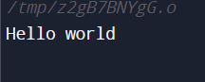

**Program:2**

**Aim:Write a program that takes two numbers as input and prints their sum.**

**Program:**

**#include<stdio.h>**

**int main()**

**{**

**int a,b,sum;**

**printf("Enter first number:");**

**scanf("%d", &a);**

**printf("Enter second number:");**

**scanf("%d", &b);**

**sum=a+b;**

**printf("Anwer is:%d",sum);**

**return 0;**

**}**

**Output:**

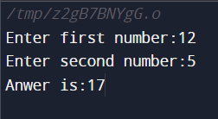

**Program:3**

**Aim:Write a c program to calculate the factorial of given positive integer.**

**Program:**

**#include<stdio.h>**

**int main()**

**{**

**int i,fact=1,number;**

**printf("Enter a number: ");**

**scanf("%d",&number);**

**for(i=1;i<=number;i++){**

**fact=fact*i;**

**}**

**printf("Factorial of %d is: %d",number,fact);**

**return 0;**

**}**

**Output:**

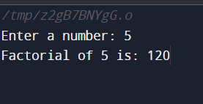

**Program:4**

**Aim:create a program that checks if a given number is even or odd.**

**Program:**

**#include <stdio.h>**

**int main() {**

**int num;**

**printf("Enter an integer: ");**

**scanf("%d", &num);**

**if(num % 2 == 0)**

**printf("%d is even.", num);**

**else**

**printf("%d is odd.", num);**

**return 0;**

**}**

**Output:**

Even number output:

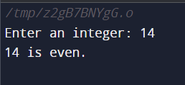

Odd number output:

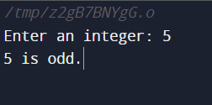

**Program:5**

**Aim:Write a program to swap the value of two variable without using a third variable.**

**Program:**

**#include<stdio.h>**

**int main()**

**{**

**int a=10, b=20;**

**printf("Before swap a=%d b=%d",a,b);**

**a=a+b;*//a=30 (10+20)***

**b=a-b; *//b=10 (30-20*)**

**a=a-b; *//a=20 (30-10)***

**printf("\nAfter swap a=%d b=%d",a,b);**

**return 0;**

**}**

**Output:**

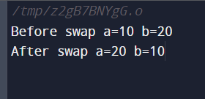

**Program:6**

**Aim:Develop a program to determine if a given number is prime or not.**

**Program:**

**#include <stdio.h>**

**int main(){**

**int num, i, c = 0;**

**printf("Enter a Number: ");**

**scanf("%d", &num);**

**for (i = 1; i <= num; i++){**

**if (num % i == 0){**

**c++;**

**}**

**}**

**if (c == 2){**

**printf("%d is a Prime Number.", num);**

**}**

**else {**

**printf("%d is not a Prime Number.", num);**

**}**

**return 0;**

**}**

**Output:**

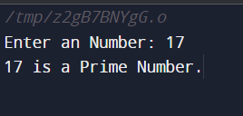

**Program:7**

**Aim:write a c program to generate the fibonacci series up to a specified term.**

**Program:**

**#include<stdio.h>**

**int main()**

**{**

**int n1=0,n2=1,n3,i,number;**

**printf("Enter the number of elements:");**

**scanf("%d",&number);**

**printf("\n%d %d",n1,n2);**

**for(i=2;i<number;++i)**

**{**

**n3=n1+n2;**

**printf(" %d",n3);**

**n1=n2;**

**n2=n3;**

**}**

**return 0;**

**}**

**Output:**

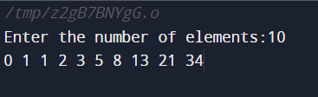

**Program:8**

**Aim:Implement a program that perfoms basic operations on an array, such as finding the sum, average,and maximum element.**

**Program:**

**#include <stdio.h>**

**int main() {**

**int arr[] = {1, 2, 3, 4, 5};**

**int n = sizeof(arr) / sizeof(arr[0]);**

**int sum = 0;**

**for (int i = 0; i < n; i++) {**

**sum += arr[i];**

**}**

**printf("Sum: %d\n", sum);**

**float average = (float)sum / n;**

**printf("Average: %.2f\n", average);**

**int max = arr[0];**

**for (int i = 1; i < n; i++) {**

**if (arr[i] > max) {**

**max = arr[i];**

**}**

**}**

**printf("Maximum: %d\n", max);**

**return 0;**

**}**

**Output:**

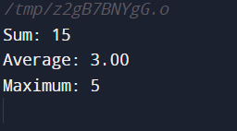

**Program:9**

**Aim:create aprogram to check if a given string is a palindrome or not**

**Program:**

**#include <stdio.h>**

**#include <string.h>**

**int main()**

**{**

**char str[10] = "naman";**

**int i, len, flag = 0;**

**len = strlen(str);**

**for (i = 0; i < len; i++)**

**{**

**// Checking if string is palindrome or not**

**if (str[i] != str[len - i - 1]) {**

**flag = 1;**

**break;**

**}**

**}**

**if (flag)**

**printf("%s is not palindrome", str);**

**else**

**printf("%s is palindrome", str);**

**return 0;**

**}**

**Output:**

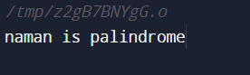

**Program:10**

**Aim:write a c program to implement a simple calculator that can perform addition,subtraction,multiplication,and division.**

**Program:**

**#include <stdio.h>**

**int main()**

**{**

**int number1, number2, addition, subtraction, multiply;**

**float divide;**

**printf("Enter Number 1\n");**

**scanf("%d", &number1);**

**printf("Enter Number 2\n");**

**scanf("%d", &number2);**

**addition = number1 + number2 ;**

**subtraction = number1 - number2;**

**multiply = number1 * number2;**

**divide = number1 / (float)number2;**

**printf("Addition = %d\n",addition);**

**printf("Subtraction = %d\n",subtraction);**

**printf("Multiplication = %d\n",multiply);**

**printf("Division = %.2f\n",divide);**

**return 0;**

**}**

**Output:**

